From Mimi’s Kitchen
I grew up eating ham for Easter. Always. My mom loved ordering a ham from Honeybaked Hams for the occasion. Now, don't get me wrong, I don't have anything against ham, I’ve order a few Honeybaked Hams myself, but here are a couple traditional Easter dishes for you to enjoy if you are burnt out on ham from Thanksgiving and Christmas like me.

Honey Roasted Rack of Australian Lamb
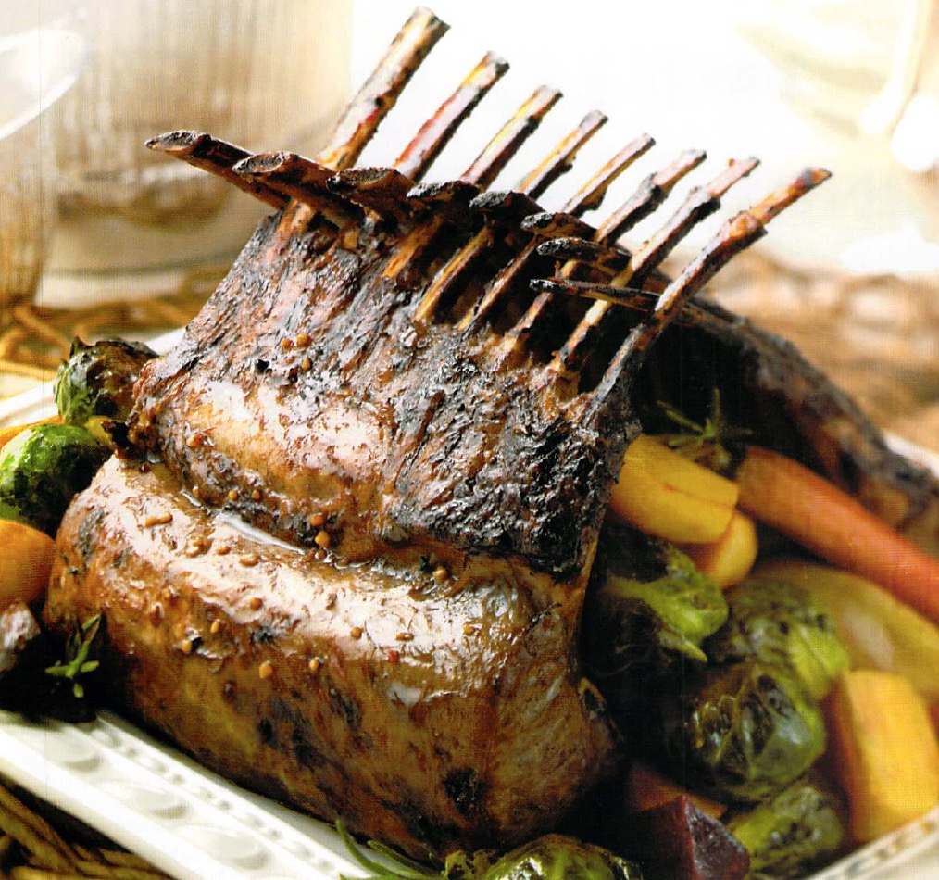
Ingredients
3 tablespoons of honey
3 tablespoons of lemon juice
3 tablespoons of soy sauce
2 teaspoons crushed garlic
1 medium 8-rib rack of Australian lamb

Directions
Preheat oven to 475 F.
In a small bowl combine honey, lemon juice, soy sauce and garlic.
Preheat a heavy skillet (cast iron if available) over high heat. Add rack of lamb and sear for 3 minutes per side. Remove and season with the honey mixture.
Place the rack of lamb, fat side up, in a roasting pan and roast in the middle of the oven for 14-16 minutes for medium-rare. Transfer the rack to a warm plate and let rest for 10 minutes before slicing. Makes 4 servings.

Herb Roasted Cornish Hens
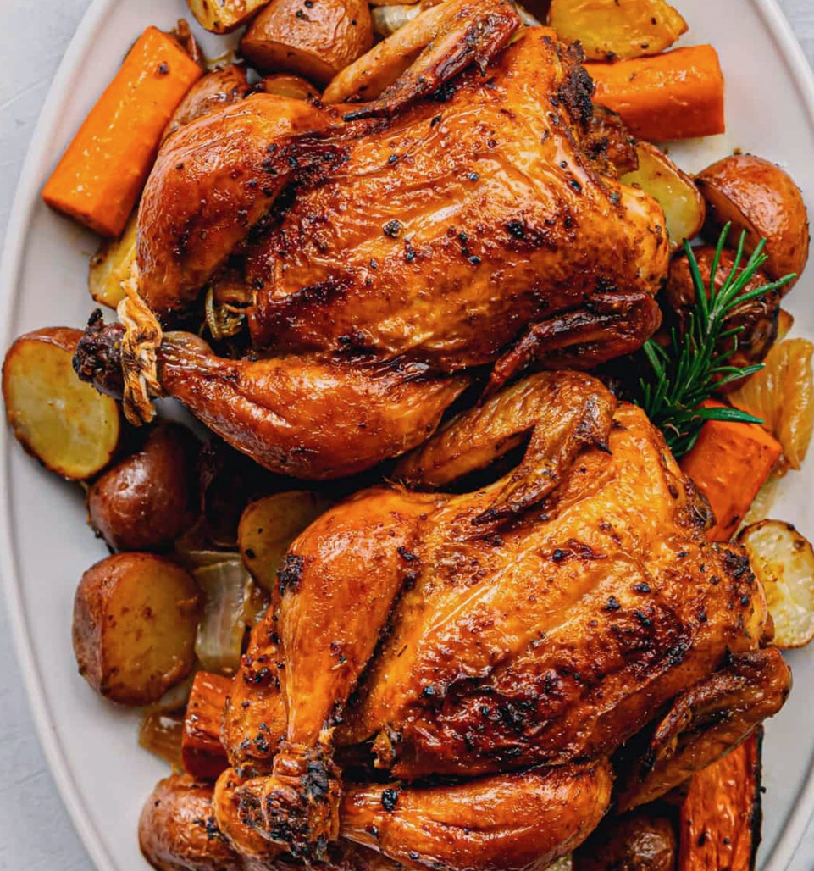
Ingredients
2 Cornish game hens (livers and gizzards removed and rinsed)
2 whole cloves of garlic (peeled)
1 1/2 large shallots (peeled and quartered)
2 large sprigs rosemary (fresh)
1-teaspoon kosher salt
1-tablespoon mustard (coarse-grained)
1 tablespoon Dijon mustard
1 1/2 teaspoons fine herbs
1/2-teaspoon paprika (sweet)
1/2-teaspoon fennel seed (crushed)
1/2-teaspoon black pepper (freshly ground)
1/2-teaspoon red pepper flakes

Directions
Preheat the oven to 350 F.
Place the Cornish hens in a large ovenproof baking dish. Place 1 clove garlic, several pieces of shallots, and 1 rosemary sprig into the cavity of each game hen. Rub 1/2-teaspoon salt into the cavity of the hens.

In a small bowl, combine mustards, fines herbs, paprika, fennel seed, pepper, red pepper flakes, and the remaining 1/2-teaspoon salt and whisk thoroughly. Then coat game hens thoroughly with the mixture.
Place the hens in the preheated oven and roast for 75 minutes. Check the temperature at the thickest part of the thigh, away from the bone, and make sure it's at least 165 F. Remove from the oven and let rest for 5 minutes before serving. Makes 4 servings.

